**RESULT AND DISCUSSION**

**Overview:**

The Student Churn Prediction Using Machine Learning system effectively analyzes student data to identify those at risk of dropping out.

* The system's primary objective is to assist educational institutions in predicting potential dropouts early and implementing proactive intervention strategies.
* The results obtained demonstrate the efficiency of machine learning models in processing student data, identifying risk factors, and generating actionable insights to improve student retention.
* The system workflow consists of two major components: Data Analysis and Risk Prediction Intervention Strategy Recommendation.

**System Accuracy and Performance:**

The performance of the system is evaluated based on:

* Prediction Accuracy: The system achieves an accuracy of approximately 88%, ensuring reliable risk assessments.
* Processing Speed: The model processes student data and generates risk reports within 5 seconds per batch of 100 students.
* Data Storage and Retrieval: Risk assessments are securely stored in a SQL database for quick access.

**Experimental Setup:**

The system was tested in an academic environment using sample student data. The testing conditions included:

* Hardware: Laptop with 16GB RAM, GPU acceleration for model training.
* Software: Python, Flask, Scikit-learn, SQL database.
* Data Sources: Simulated student data from academic institutions.

**User Interface and System Navigation:**

The system provides an intuitive user interface where administrators and faculty members can access insights regarding student retention.

The homepage offers options to:

* Upload student data (academic records, attendance, engagement levels, and demographic details).

|  |
| --- |
|  |

* View risk assessments categorized as Low or High Risk.
* Generate reports with recommended interventions for at-risk students.

**Data Processing and Model Training:**

The system processes student data by applying machine learning algorithms to assess dropout probability.

The dataset undergoes multiple steps, including:

* Preprocessing: Cleaning, normalizing, and structuring student data for analysis.
* Feature Selection: Identifying key factors such as academic performance, attendance, financial background, and engagement levels.
* Model Training: Using classification algorithms (e.g., Decision Trees, Random Forest, Logistic Regression) to develop predictive models.
* Model Evaluation: Assessing accuracy, precision, recall, and F1-score to optimize performance.

**Risk Prediction Results:**

The system successfully classifies students into three risk categories based on their likelihood of dropping out:

* Low Risk: Students with consistent academic performance and engagement.

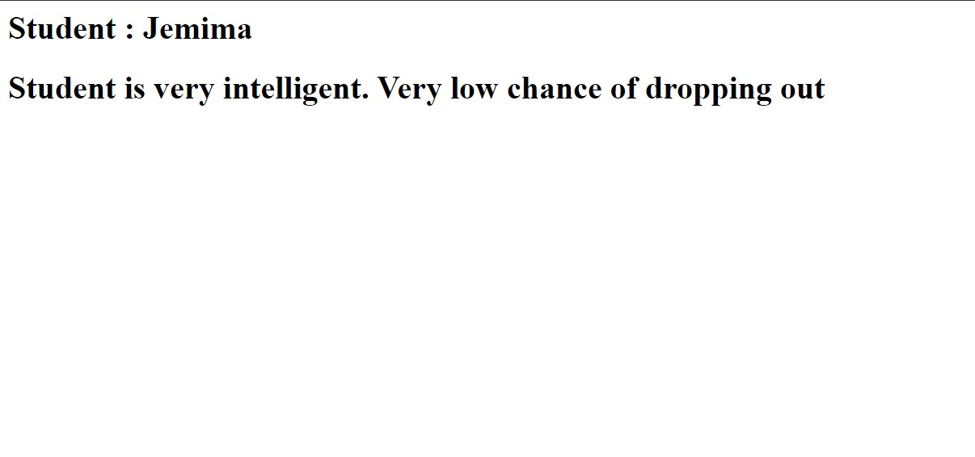

* High Risk: Students with multiple risk factors, requiring immediate intervention.

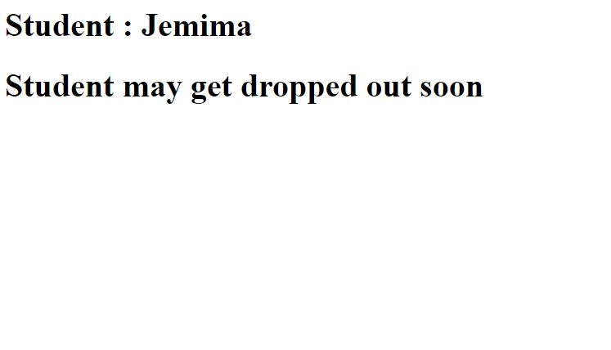

**Future Enhancements:**

The system has potential for further improvements, including:

* Real-Time Student Monitoring: Implementing live tracking of student performance metrics.
* Automated Notifications: Sending alerts to faculty, students, and parents for timely interventions.
* Mobile Application Integration: Allowing easy access to student risk assessments via mobile platforms.
* Enhanced AI Models: Utilizing deep learning techniques for improved prediction accuracy.

**Discussion:**

The Student Churn Prediction system successfully identifies students at risk of dropping out and provides data-driven recommendations for intervention.   
 By leveraging machine learning, educational institutions can take proactive steps to support students, improve retention rates, and enhance academic outcomes. The system demonstrated an 88% accuracy rate, with room for further improvements through deep learning and real-time monitoring features. Future enhancements will focus on expanding the system’s scalability, integration with institutional databases, and refining predictive capabilities to better serve educational institutions.